NAME: PARVENDHAN C
REG NO: 241801197
COMPETITIVE PROGRAMMING
PROGRAM 1: Finding Duplicates-O(n^2) Time
Complexity,O(1) Space Complexity
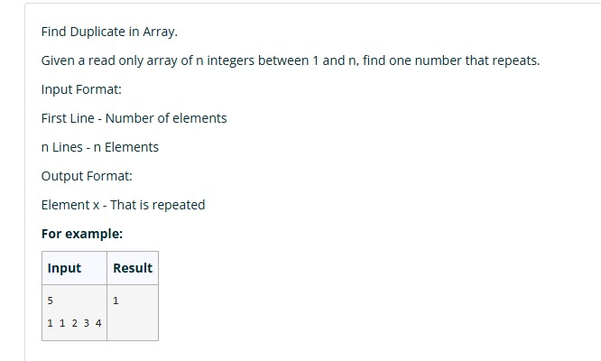
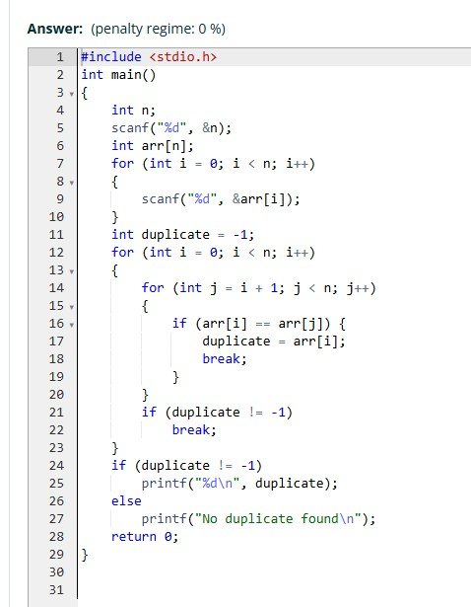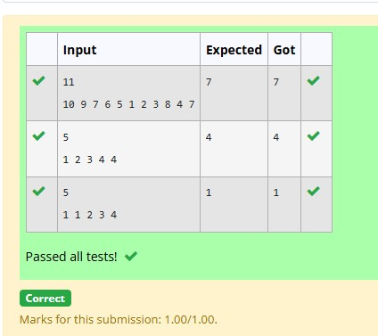

PROGRAM 2: Finding Duplicates-O(n) Time
Complexity,O(1) Space Complexity
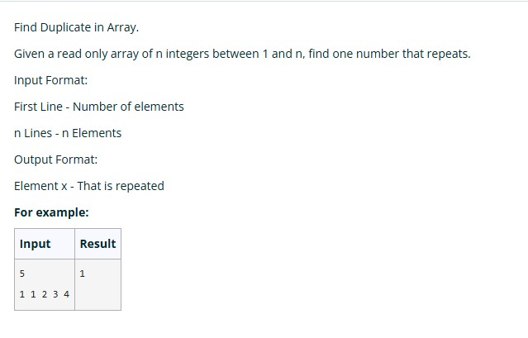
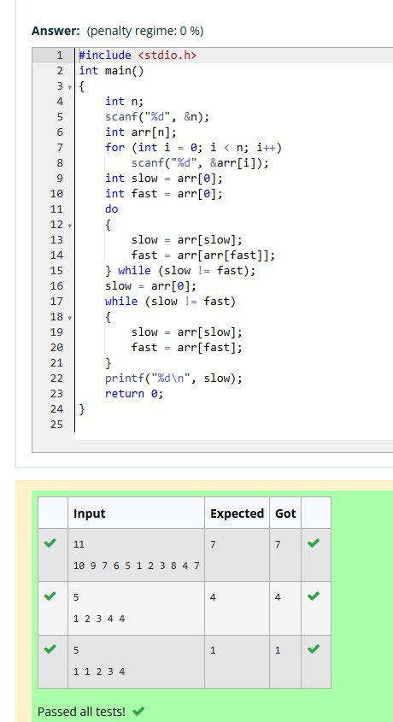

PROGRAM 3: Print Intersection of 2 sorted arrays-O(m*n)Time Complexity,O(1) Space
Complexity
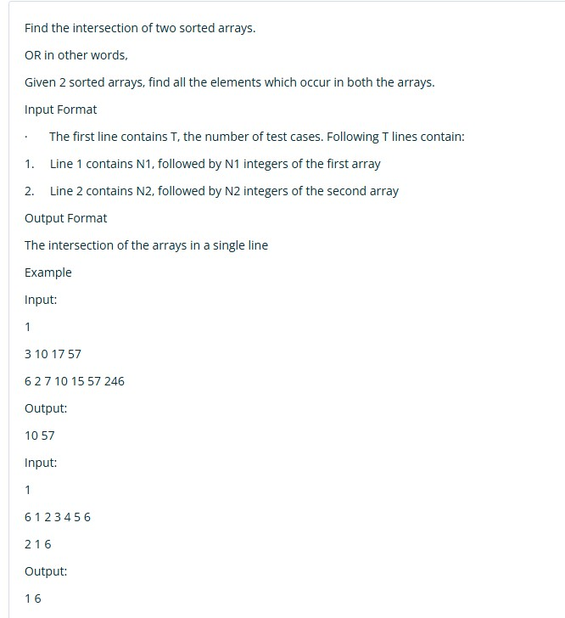
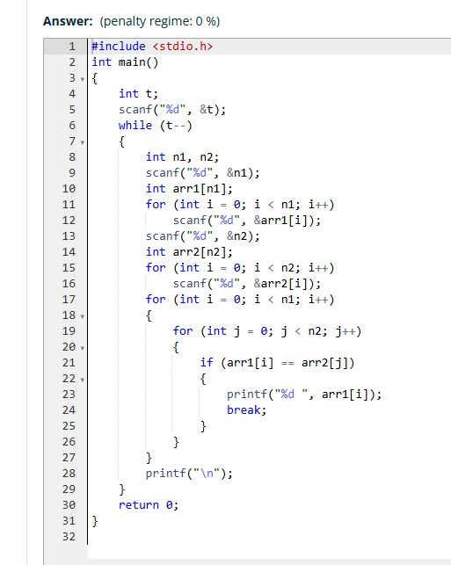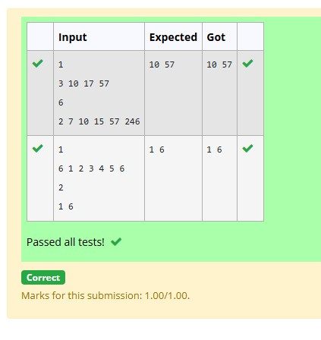

PROGRAM 4:Print Intersection of 2 sorted arrays-O(m+n)Time Complexity,O(1) Space
Complexity
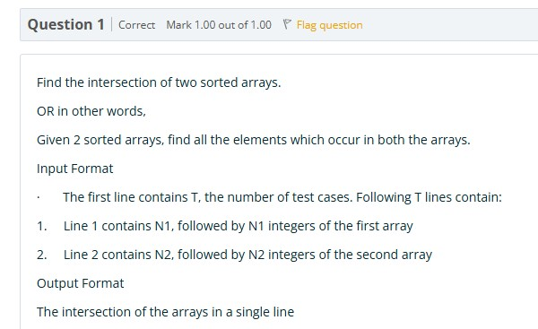
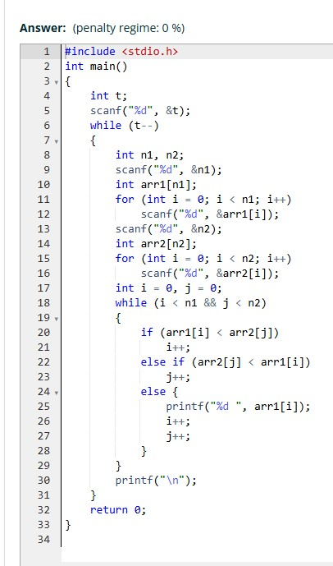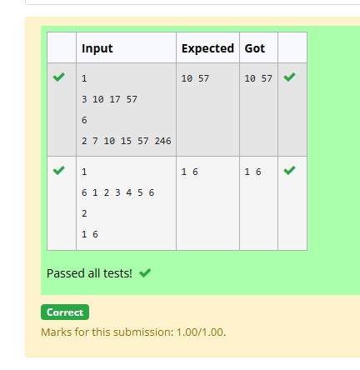

PROGRAM 5: Pair with Difference-O(n^2)Time
Complexity,O(1) Space Complexity
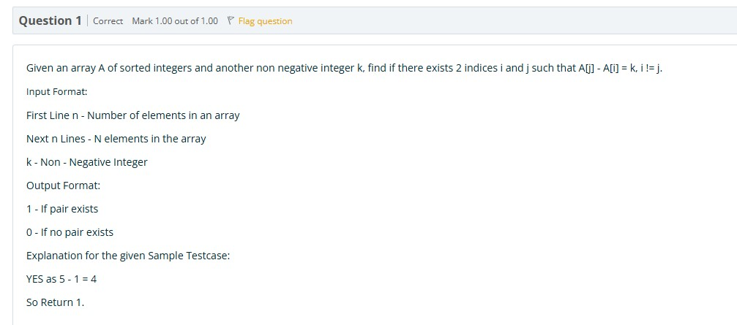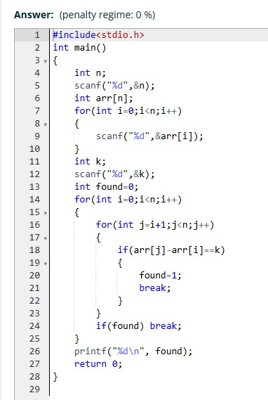

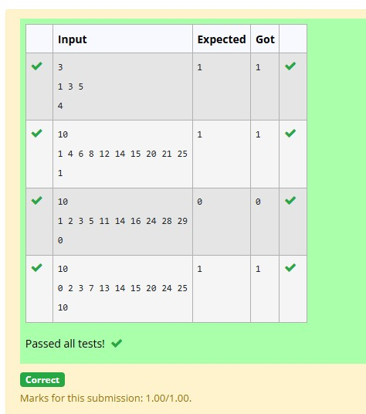

PROGRAM 6: Pair with Difference -O(n) Time
Complexity,O(1) Space Complexity
